Piyushgoel288@gmail.com

About

A web browser (commonly referred to as a browser) is application software for accessing the World Wide Web. When a user requests a web page from a particular website, the web browser retrieves the necessary content from a web server and then displays the page on the user's device.

Web Browser’s

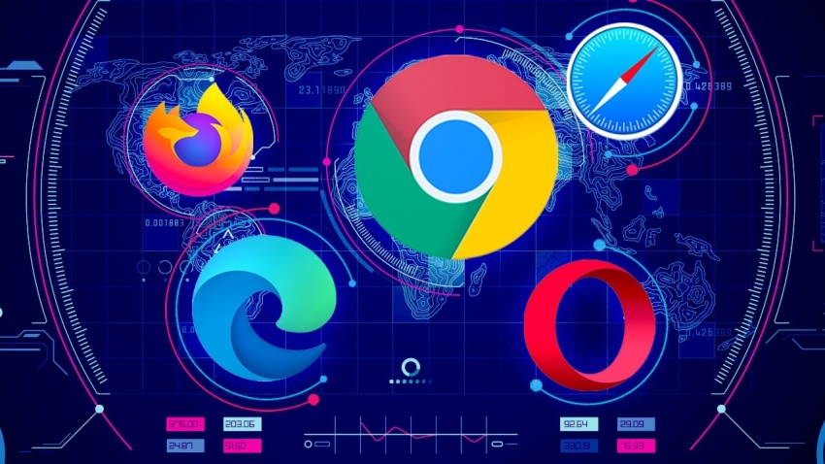

|  |  |  |  |  |  |
| --- | --- | --- | --- | --- | --- |
|  | | |  | Microsoft Edge | |
| **Initial release date**: - 29April 2015 |  |
| About Microsoft Edge is an internet browser made by Microsoft, which is installed by default on all new Windows computers. Edge was made to replace Internet Explorer, and runs faster and with more features. Microsoft has made a big effort with [Edge](https://www.businessinsider.com/category/microsoft-edge) to improve the browsing experience, and it's paid off. Microsoft Edge has enough features and benefits that it's actually a real alternative to more popular browsers like Chrome or Firefox.  This is especially true with the [Edge's most recent update](https://www.businessinsider.com/microsoft-new-edge-browser-great-almost-identical-to-google-chrome-2020-1), which overhauled how the browser runs and operates. | |
|  | https://www.microsoft.com/en-us/edge **Features** Microsoft Edge is the default web browser on Windows 10, Windows 10 Mobile, Windows 11, Xbox One, and Xbox Series X and Series S consoles, replacing Internet Explorer 11 and Internet Explorer Mobile.[22] As its development and release is dependent on the model of Windows as a service, it is not included in Windows 10 Enterprise Long-Term Servicing Channel (LTSC) builds.  Microsoft initially announced that Edge would support the legacy MSHTML (Trident) browser engine for backwards compatibility, but later said that, due to "strong feedback," Edge would use a new engine, while Internet Explorer would continue to provide the legacy engine.[26]  Favorites, reading list, browsing history and downloads are viewed at the Hub,[27] a sidebar providing functionality similar to Internet Explorer's Downloads manager and Favorites Center | |
|  |  |  |
|  |  | |
|  |  |  |
|  |  | |
|  |  |  |
|  |  | |
|  |  |  |



# About

Google Chrome is a cross-platform web browser developed by Google. It was first released in 2008 for Microsoft Windows, built with free software components from Apple Web Kit and Mozilla Firefox.[12] It was later ported to Linux, macOS, iOS, and Android, where it is the default browser.[13] The browser is also the main component of Chrome OS, where it serves as the platform for web applications.

Most of Chrome's source code comes from Google's free and open-source software project Chromium, but Chrome is licensed as proprietary freeware.WebKit was the original rendering engine, but Google eventually forked it to create the Blink engine;[14] all Chrome variants except iOS now use Blink.[15]

As of October 2021, Stat Counter estimates that Chrome has a 68% worldwide browser market share (after peaking at 72.38% in November 2018) on personal computers (PC),[16] is most used on tablets (having surpassed Safari), and is also dominant on smartphones,[17][18] and at 65% across all platforms combined.[19] Because of this success, Google has expanded the "Chrome" brand name to other products: Chrome OS, Chromecast, Chromebook, Chromebit, Chromebox, and Chromebase.

GOOGLR CHROME

https://www.google.com/chrome/?brand=FHFK&gclid=Cj0KCQiAzMGNBhCyARIsANpUkzORUVsVbtPwCY6RUm2nL2QZa3YWO-_7co2ieo7Q3hvm7QGTxXkmpFYaAjP3EALw_wcB&gclsrc=aw.ds

## **Features**

Features of the desktop edition include tabbed browsing, full-screen mode, spell checking, incremental search, smart bookmarks, bookmarking and downloading through drag and drop,[54][55] a download manager, user profile management,[56] private browsing, bookmark tags, bookmark exporting,[57] offline mode,[58] a screenshot tool, web development tools, a "page info" feature which shows a list of page metadata and multimedia items,[59] a sophisticated configuration menu at autoconfigure for power users, and more location-aware browsing (also known as "geolocation") based on a Google service,[60] and an integrated search system, which uses Google by default in most markets.[61] Additionally, Firefox provides an environment for web developers in which they can use built-in tools, such as the Error Console or the DOM Inspector, and extensions, such as Firebug and more recently there has been an integration feature with Pocket. Firefox Hello was an implementation of WebRTC, added in October 2014, which allows users of Firefox and other compatible systems to have a video call, with the extra feature of screen and file sharing by sending a link to each other. Firefox Hello was scheduled to be removed in September 2016.[62]

Former features include the ability to block images from individual domains (until version 72),[63] a 3D page inspector (versions 11 to 46), tab grouping (until version 44), and the ability to add customized extra toolbars (until version 28)

Initial release date: -

2 September 2008



Mozilla Firefox



Initial release date:- 23 September 2002

## **Features**

Features of the desktop edition include tabbed browsing, full-screen mode, spell checking, incremental search, smart bookmarks, bookmarking and downloading through drag and drop, a download manager, user profile management, private browsing, bookmark tags, bookmark exporting, offline mode,[58] a screenshot tool, web development tools, a "page info" feature which shows a list of page metadata and multimedia items,[59] a sophisticated configuration menu at autoconfigure for power users, and more location-aware browsing (also known as "geolocation") based on a Google service, and an integrated search system, which uses Google by default in most markets.

https://www.mozilla.org/en-US/firefox/new/

# About

Mozilla Firefox or simply Firefox is a free and open-source[19] web browser developed by the Mozilla Foundation and its subsidiary, the Mozilla Corporation. Firefox uses the Gecko rendering engine to display web pages, which implements current and anticipated web standards. In 2017, Firefox began incorporating new technology under the code name Quantum to promote parallelism and a more intuitive user interface.[21] Firefox is available for Windows 7 and later versions, macOS, and Linux.



Opera (web browser)



https://www.opera.com/

## **Features**

Opera has originated features later adopted by other web browsers, including: Speed Dial, pop-up blocking, re-opening recently closed pages, private browsing, and tabbed browsing. Additional features include a built-in screenshot tool called Snapshot which also includes an image-markup tool, built-in ad blockers and tracking blockers.

# About

Opera is a multi-platform web browser developed by its namesake company Opera. Opera is nowadays a Chromium-based browser. It distinguishes itself from other browsers through its user interface and other features.

Opera was initially released on April 10, 1995, making it one of the oldest desktop web browsers still actively developed today. It was a commercial software for the first ten years and had its own proprietary Presto layout engine. In 2013, Opera switched from the Presto engine to Chromium.

The web browser can be used on Microsoft Windows, Android, iOS, macOS, and Linux operating systems.There are also mobile versions called Opera Mobile and Opera Mini. Additionally, Opera users have access to a news app based on an AI-platform, Opera News.

The company released a gaming-oriented version of the browser called Opera GX in 2019

**Initial release date**: -

10 April 1995

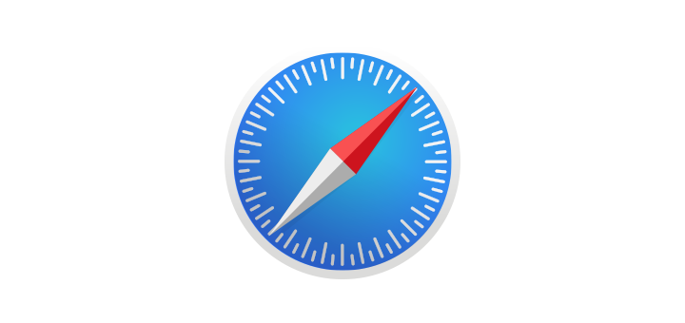

Safari

**Initial release date**: -

7 January 2003



# About

Safari is a graphical web browser that is developed by Apple. It is primarily based on open-source software properties, and mainly Web Kit. It succeeded Netscape Navigator, Cyberdog and the most recent Internet Explorer for Mac as the default web browser for Macintosh computers. It is supported on macOS, iOS, and iPadOS; a Windows version was offered from 2007 to 2010.

Safari was introduced within the Mac OS X Panther in January 2003, and as of 2021, spawned a total of 15 revisions. The third generation (January 2007) brought compatibility to the iPhone via iPhone OS 1, while the Macintosh edition was topped with the fastest browser performance at that time. The fifth version (June 2010) made uses of a less distracted screen reader, extension and developer tools; it was also the final version for Windows. In the eleventh version (September 2017), it added supports for the Intelligent Tracking Prevention. The thirteenth version included various privacy and application updates such as the FIDO2 USB security key authentication and Web Apple Pay support. The fourteenth version (November 2020) was the most-previous revision of Safari. The 2020 version was 50% faster than Google Chrome, and it consumed less battery than other standard competitors. The fifteenth version (July 2021) was the current revision, featuring a redesigned interface.

https://www.apple.com/in/safari/

## **Features**

Apple used a remotely updated plug-in blacklist to prevent potentially dangerous or vulnerable plugins from running on Safari. Initially, Flash and Java contents were blocked on some early versions of Safari. Since Safari 12 support for NPAPI plugins (except for Flash) has been completely dropped. Starting with the release of Safari 14, support for Adobe Flash Player will be dropped altogether